Template for ECCC2021
Influences of cold deformation and very low strain rate on the creep and mechanical behaviour of Sanicro 25 material

G. Chai^{1,} ^{2*}, P. Barnard³, M. Olaison¹ and G. McMillan³

¹Sandvik Materials Technology, SE-811 81 Sandviken, Sweden
²Engneering Materials, Linköping University, 581 83 Linköping, Sweden
³Doosan Power Systems, Manor Royal, Crawley, West Sussex, United Kingdom, RH10 9AD
*guocai.chai@sandvik.com

Summary
Sanicro 25 is a newly developed high performance heat resistance austenitic stainless steel, which shows a good combination of high resistances to steam oxidation and hot corrosion, and very high creep rupture strength. This makes ……….

Key Words
Advanced coal power plants, heat resistant austenitic stainless steels, Sanicro 25, cold deformation, ductility, creep, fatigue.

Introduction
The demand for electric power has been continuously increasing around the world. Meanwhile the consciousness of the environmental impact from human action is growing. Although combustion processes generate carbon dioxide, ………..
.

Material and experimental details
The material used was a tube material with a dimension of 38x8.8 mm. Table 1 shows the chemical composition of Sanicro 25. To study the influence of cold deformation on the creep behaviour, test samples were cut out of the wall and…………….
.

Results and discussion
Effect of cold deformation
The influence of cold deformation on the creep property up to 38 000 hours at 650°C and 700°C is shown in Figure 1. The results show……….

Effect of very slow strain rate
Figure 2 shows the influence of very slow strain rate testing on the tensile properties of Sanicro 25 material. The results show that…………
.
Effect of cold deformation plus annealing
The influence of annealing after cold deformation is shown in Figure 7. The results show that performing an annealing cycle after………

Tables and Figures

Table 1 Chemical composition of Sanicro 25 (wt%)
C | Si | Mn | Cr | Ni | W | Co | Cu | Nb | N
<0.1 | 0.2 | 0.50 | 22.5 | 25.1 | 3.58 | 1.5 | 3.0 | 0.47 | 0.23

Table 2 Test plan for creep testing of the cold deformed Sanicro 25 material

Table 3 Test plan for creep testing of the cold deformed plus solution annealed Sanicro 25 material (1215°C/30 minutes/air)

NOTE: Materials at High Temperature usually has tables and pictures embedded within the text. If you would prefer to submit with tables and pictures after the text that is perfectly acceptable.

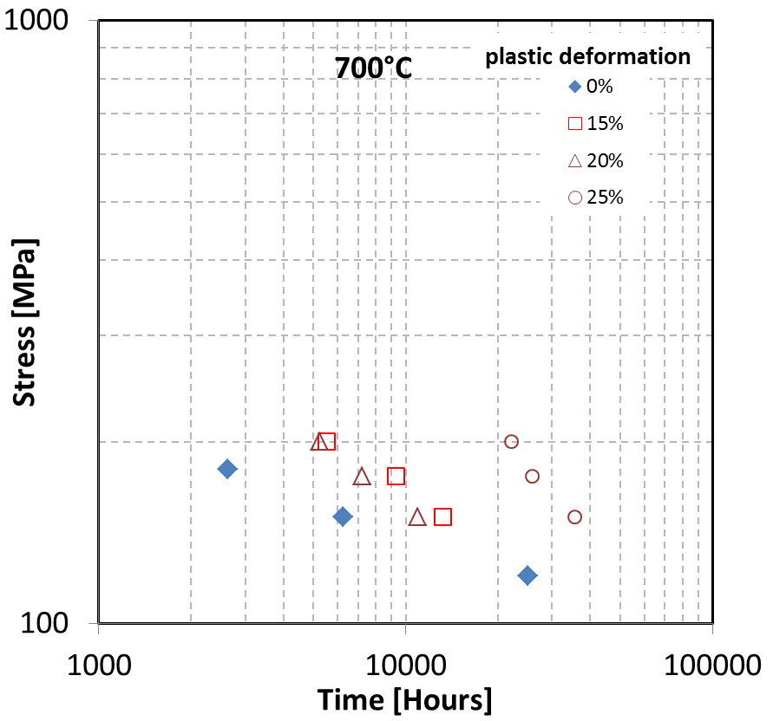
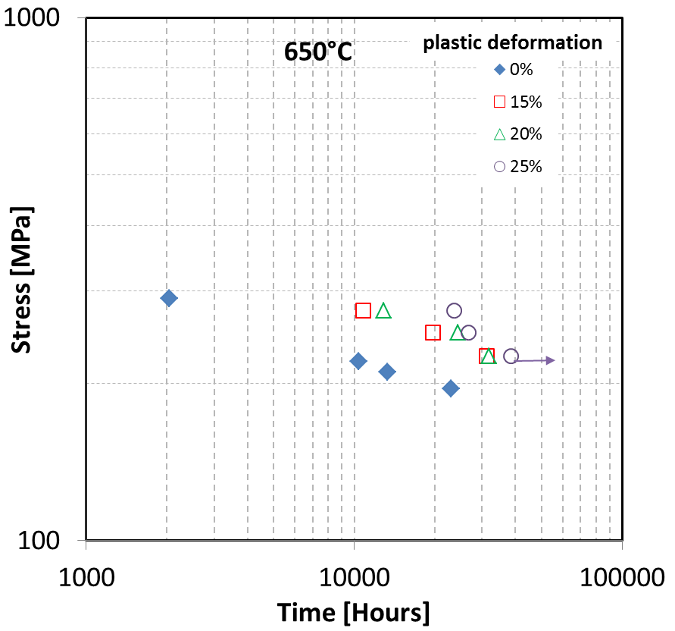

(a)
(b)

Figure 1 Influence of cold deformation on the creep properties of Sanicro 25 tube material with a dimension of 38x8.8 mm, (a) creep test at 650°C, (b). Creep test at 700°C.

Conclusion
The influences of cold deformation and very low strain rate on the creep and mechanical behaviour of Sanicro 25 material were studied in this paper. The followings can be concluded.

A cold deformation up to 25% plastic deformation will generally increase the creep strength of the material at 650-700°C, ………….

Acknowledgments
This paper is published by permission of Sandvik Materials Technology. Supports from Mr Pasi Kangas and Mr Glenn Darley are greatly acknowledged.

References
[1] IEA, https://www.iea.org/publications/freepublications/publication/KeyWorld2016.pdf.
[2] J. Bugge, AD 700-Advanced 700°C PF power plants, http://www.unece.org/fileadmin/DAM/ie/se/pdfs/ AD700PFCoal.pdf.
[3] S. Kjaer, et al., The advanced supercritical 700°C pulverized coal-fired power plant, Powergen Europe 2001, Brussels, May, 2001.

Additional Notes to Authors.

Do you wish your paper to be submitted to Materials at High Temperatures………………Yes/No

An abstracts book will be included within the delegate pack as below. You are invited to include a photo of the main author/presenter, to aid networking at the conference. If you prefer not to supply a photo we will happily include the abstract without a photo.
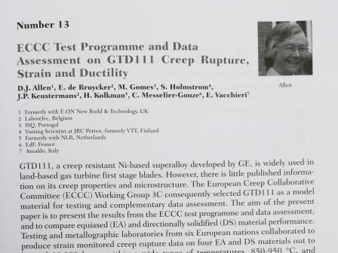
Many attendees also like to obtain copies of the presentation, which may be slightly different content to the paper. If you are happy to allow, we will include your presentation on the USB provided with the delegate pack.

Do you wish your presentation included on the USB provided to delegates………………Yes/No

Any questions relating to paper/presentation and submission to paper please contact the Chair of the Scientific Committee Dr Augusto Di Gianfrancesco, a.digianfrancesco@libero.it

Any questions relating to the organisation of the conference, registration or administration please contact the Chair of the Organising Committee Dr Peter Barnard, peter.barnard@doosan.com

